Ahsanullah University of Science and Technology

Department of Computer Science and Engineering

CSE 2210: Digital Electronics and Pulse Techniques Sessional

## **Section: B2**

## **Experiment Time: 30 Minutes Submission Time: 10 mins**

## **Submission End Time: 4:30 PM**

**Experiment # 4**

**Name of the experiment: Study of an RTL NOR gate.**

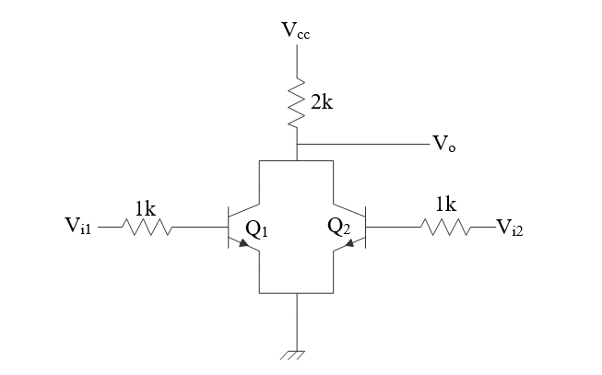

Procedure:

1. Measure the output voltage (*V*0) for all possible input combinations.
2. Connect the *V*i1 input to ground, vary *V*i2 and measure *V*0.
3. Connect the *V*i2 input to ground, vary *V*i1 and measure *V*0.

Questions:

1. Analyze the operation of RTL NOR gate with the experimental data.
2. What is the importance of studying the RTL gate? [Hint: Millman pg. 162]
3. Draw the *V*0 vs. *V*i1 and *V*i2 curves.

Report:

1. Objective.
2. Circuit diagram
3. Answer to the questions.
4. Experimental data.
5. Calculations. (Not required for this experiment)
6. Discuss the findings.